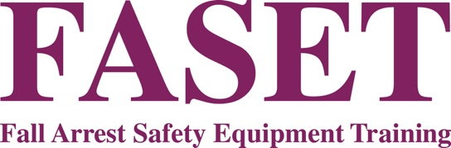

ANNUAL GENERAL MEETING

**11am THURSDAY 20TH NOVEMBER 2025 (with registration from 10am)**

**WORSLEY PARK, WORSLEY, MANCHESTER, M28 2QT**

## AGENDA

1. WELCOME AND APOLOGIES
2. MINUTES OF THE PREVIOUS ANNUAL GENERAL MEETING – 28th November 2024

3. ELECTION OF THE FASET BOARD

To note that:

Robert Harris, John Howard & Chris Massey have retired by rotation and offer themselves for re-election.

Julie Cheetham of Safe Edge Ltd has resigned her post.

4. FASET FINANCIAL REPORT

4.1 Accounts Year End 31st December 2024

4.2 Provisional Report for 2025 & Annual Income and Expenditure Budget for 2026

6. ANY OTHER BUSINESS

Following the formal business of the AGM, a number of interesting presentations will be given on subjects very relevant to our industry. There will also be opportunities for members to have their say on the direction of the organisation.