FASET – Tool Box Talk No. 4 (11th September 2015)
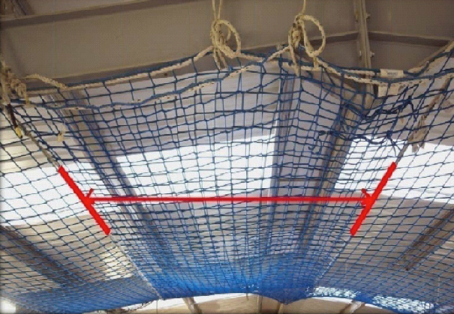
Joining Safety Nets Together

Where Safety Nets are ‘overlapped’ there must be a minimum of 2 meters (or 20 meshes) throughout length of the overlap (see Figure 1).

When overlapping Safety Nets, the upper net must overlap the lower net. This practice is called ‘Tiling’.

Figure 1
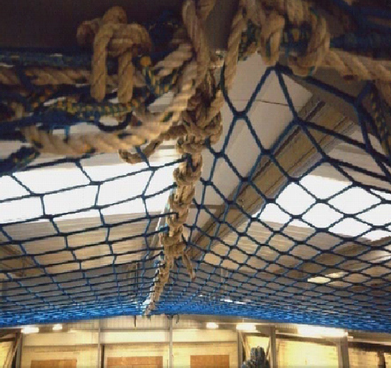
Where a 2m overlap cannot be achieved, Safety Nets must be laced together using a rope with a minimum 7.5kN breaking strain (type O, as demonstrated in Figure 2) or above.
The rope must pass through at least every other mesh and both border ropes must be laced together.
The ends of the rope must be tied off at the corners.
Figure 2

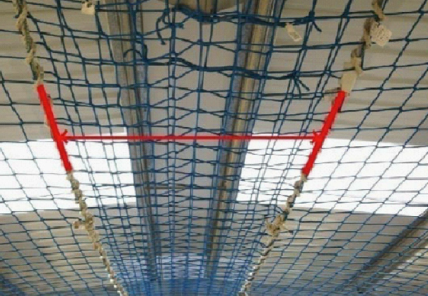
NB: The practice of “Pinning” Safety Nets has been withdrawn as a FASET recommendation after 01/01/12.

