FASET – Tool Box Talk No. 3 (15th September 2014)

**MEWP & Workplace Pre Start Checks**

**Workplace Inspection**

Before the aerial platform is put into service, the operative will check the area in which the MEWP is to be used for possible hazards such as, but not limited to:

1. Drop offs/holes including those concealed by water, ice, mud etc
2. Slopes
3. Bumps floor obstruction
4. Debris/site rubbish
5. Overhead obstructions/electrical conductors
6. Hazardous locations/atmospheres
7. Inadequate surface/support to withstand all load forces imposed by the aerial platform in all operating modes
8. Weather conditions (including wind)
9. Presence of other trades/site operatives also any unauthorised persons.
10. Any other unsafe conditions.

**Cherry Picker Pre-start**

Before use each day or shift the MEWP will be given a visual inspection and functional test including, but not limited to the following:

1. Current in-service inspection (LOLER)
2. Operating and emergency controls
3. Safety devices
4. Personal protective devices
5. Air, hydraulic and fuel systems leaks
6. Engine cooling system, water, engine oil and hydraulic oil levels
7. Cables and wiring
8. Loose or missing parts
9. Tyres, wheels and brakes
10. Placards, warnings, control markings and operating manual(s)
11. Stabilisers, outriggers and other structures.
12. Guardrail systems
13. Any additional items specified by the manufacturer.
14. The MEWP ignition key will be left in the ground controls and cannot be removed from the MEWP whilst in service.
15. All MEWP’s operated by a FASET member is to include a “Secondary guarding device”
16. MEWP’s used through a 3rd party that does not include “Secondary guarding device” must contact their M4M before works commence in the MEWP. *(Subject to Specific Risk Assessment)*
17. Check that a rescue / emergency plan / procedure is in place.

**Ground Conditions, Temporary Works and Supporting Structures**

It is the Principal Contractors responsibility to ensure that the ground conditions including

supporting structures and traffic routes are suitable for the loads to be imposed by the MEWP and associated equipment, attachments, materials, personnel etc.

Prior to work commencing on site the Principal Contractor should provide details of ground bearing capacity and load bearing capability of supporting structures including the location of any service ducts, chambers, restrictions etc. to the Contractor selecting the MEWP.

The netting contractor shall provide details of the intended imposed loads etc to the Principal Contractor who will satisfy themselves that these are within the capacity of the ground / supporting structure including any temporary works.

During the MEWP operation the Contractor will cooperate to ensure that the imposed loads do not exceed those capacities.

The Principal Contractor in co-operation with the Contractor shall monitor the ground conditions etc to identify any deviation from the planned loadings or any ground movement, deflection of the temporary works / supporting structure.



**Planning for Specific Risks - *Secondary Guarding Devices***

All 3b MEWPs operated by FASET members shall be fitted with a manufacturer approved ‘Secondary Guarding Device / System available for the selected MEWP.

The Contractor will select the most appropriate device / system for the risks associated with

the tasks to be undertaken supported by a suitable risk assessment.



**Specific Risks - *Lifting and Handling Materials***

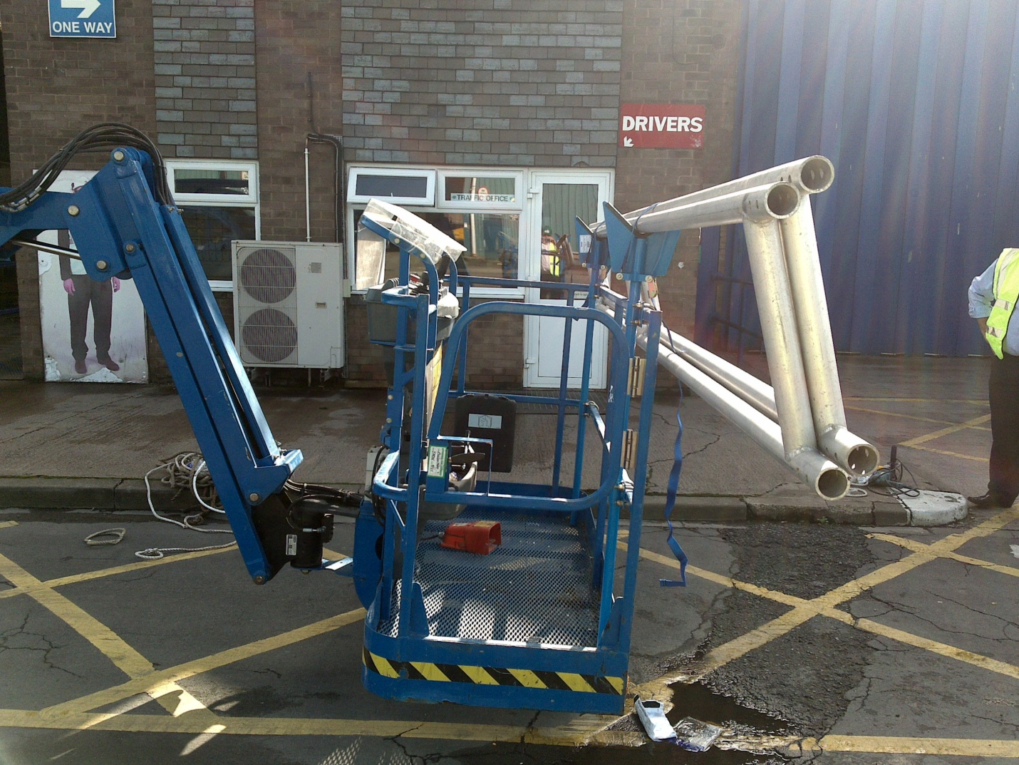

Where materials are lifted to height, a specific risk assessment is required to identify how such equipment will be raised / lowered safely.

Where material / equipment is carried that extends beyond the confines of the MEWP basket / platform the material / equipment must be secured using a manufacturer / hirer approved and compatible material handling device.

Where the material has a large surface area the maximum rated operational wind speed of the MEWP should be reduced to compensate for the increased wind resistance “sail effect” the material may impose.

The Contractors MEWP Manager should review such selected devices to ensure they are

suitable for the MEWP / task. The effect of imposed loads on the MEWP, ground, supporting

structure and temporary works shall also be considered.

Do not ever put anything in the MEWP basket that may overload it.

**Familiarisation**

All MEWP operators must hold a Log Book or similar record that can be used by the Operator to record / demonstrate experience of the particular machine to be used.

If the Operator cannot demonstrate previous experience with a particular MEWP, then that person must undergo a familiarisation procedure before commencing work.

**Taking Delivery of MEWPS**

Delivering / collection, loading / offloading of MEWPS will be in accordance with the Project

Traffic Management arrangements including the requirements for marshalling and banking.



The same precautions are required whether un/loading on the highway / off-site or on the construction site.

MEWP movement to and from work areas must be undertaken in a controlled manner.

The delivery company must also have suitable procedures for the loading and off-loading of equipment including how the delivery driver will be protected from falls when working at height.

Check the machine that is delivered is what was ordered.

**Any MEWP arriving at site must have:**

**Valid report of thorough inspection certificate,**

***(To be kept with the MEWP at all time)***

**An operating manual for the MEWP**