FASET – Tool Box Talk No. 1 (15th September 2014)

**PPE (Personal Protective Equipment) & Harnesses**

**PPE - Personal Protective Equipment**

Some dangers arising from hazardous activities can only be controlled by the use of wearing personal protective equipment (PPE)

In many cases, it is not possible to completely eliminate hazards by other means.

**What is PPE.**

* PPE is equipment or clothing worn to protect the user from hazards in the workplace.
* In construction / safety net rigging, the most commonly worn items of PPE are safety helmets, high-visibility clothing, safety footwear, full body harness, gloves & glasses.
*  Other examples of PPE are ear plugs, respirators, googles & other clothing ie overalls.

**Limitations.**

* PPE will only protect the user
* It must be used in accordance with the manufactures instructions & any training provided.
* The actual level of effectiveness is difficult to assess.
* It must be in good condition to be fully effective, do not mistreat PPE, your health & life may depend on it.

**What your employer must do.**

* Assess the risks to your health & safety arising from your work activities.
* Try to organise work activities so that PPE is not necessary.
* Where PPE is necessary, select the appropriate items that suit the wearer & are CE-marked.
* Supply you with the necessary PPE free of charge.
* Train you to use relevant PPE, explain its limitations & explain the implications of not using it.
* Ensure compatibility if more than one item of PPE is worn together.
* Ensure that PPE is maintained & replace defective or lost PPE.

**What you must do.**

* Use PPE in accordance with instructions & training given.
* Never adjust / adapt your PPE
* Return PPE to its storage, where provided, after use.
* Take reasonable care of your PPE & report its loss or any damage to your employer.
* Never work without PPE when it is known to be necessary.



**Harnesses**

**MANDATORY WEARING OF SAFETY HARNESSES**

The use of a safety harness / lanyard is mandatory whilst working

with an type B elevated work platform on every site

Your safety harness must be attached to the designated

anchorage point within the work platform basket

Safety harnesses & lanyard must be inspected for

any damage or tears on a daily basis

Report any damage immediately to your supervisor.

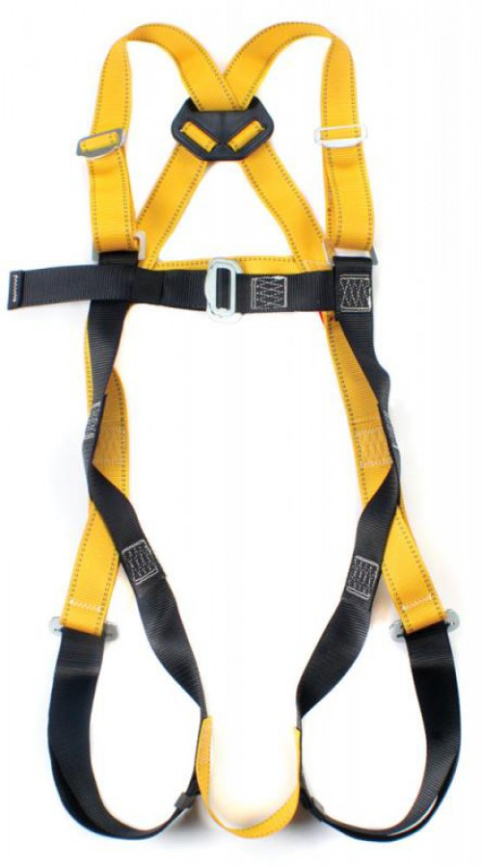

**Harness Familiarisation &**

**Own Harness Inspection**

**What should you know about fall protective equipment?**

* Every harness comes with a label & serial number. These

numbers should be clearly visible, you & your supervisor

should make a note of these for future inspection.

* Inspect your equipment daily.
* Replace defective equipment. If there is any doubt about

the safety of the equipment, do not use it & refer questionable

defects to your supervisor.

* Replace any equipment, including ropes, involved in a fall.

Refer questionable defects to your supervisor.

* Every piece of fall arrest equipment should be inspected &

certificated at least every 6 months by competent

person.

* It is advisable to use shock absorbers if the arresting forces of

the lanyard alone can cause injury.

* Short Restraint lanyards are to be used when operating a mewp.

This will stop the operative from standing on the guardrails.

**How do you inspect the webbing (body of belt, harness & or lanyard)?**

* Inspect the entire surface of webbing for damage. Beginning at one end, bend the webbing in an inverted “U”. Holding the body side of the belt towards you, grasp the belt with your hands six to eight inches apart.
* Watch for frays, pulled or broken fibres, pulled stitches, signs of abrasion, excessive wear, cuts, chemical / burn damage, altered or missing parts. Broken webbing starts generally appear as tufts on the webbing surface.
* Refer defects to your supervisor / Replace according to the manufactures guidelines.

**How do you inspect the Buckle, D-Ring, Karabiners?**

* Inspect the buckle, D-Rings & Karabiners for distortion, deformation, fractures, cracks corrosion, sharp edges missing or loose parts & improper function.
* Check pivot points are tight fitting but can be moved freely & and spring action Karabiners return back to the original position, all locking screws to move freely.
* Inspect all plastic components, back D-Ring locator, chest strap guide for broken or excessively worn parts, loose parts, inspect for signs of burns & excessive heat or chemical exposure.

**How do you inspect the rope?**

* Rotate the rope lanyard & inspect from end to end for fuzzy, worn, broken or cut fibres. Weakness areas have noticeable changes in the original rope diameter.
* Replace when the rope diameter is not uniform throughout, following a short break-in period.

**How do I clean my harness & lanyard?**

* Wipe of all surface dirt with a sponge dampened with plain water. Rinse the sponge & squeeze it dry before continuing.
* Wipe the equipment dry with a clean cloth, hang freely to dry, away from direct heat & out of direct sunlight.
* Store in a clean & dry area away from direct sunlight, corrosive materials & in such a way it does not warp or distort.

